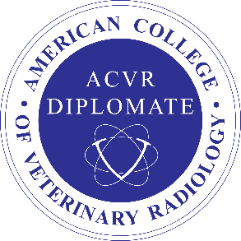
VCA-Colonial Animal Hospital

This study was performed at the

request of The Wellness Center for Pets

Ultrasound Report

Date: 2-10-22

Patient: Placid Sloan
Case No.: 65665-22

Ultrasonographic Study Performed:
Abdomen.

Ultrasonographic Findings:
The liver was considered in the upper normal limits in size, had a very slightly rounded contour and was in the upper normal limits in echogenicity. No significant changes were seen with the biliary system. The G-I tract, body of the pancreas and the right and left limbs of the pancreas appeared to be normal. The right and left kidneys were considered normal in size, shape and echogenicity and respectively measured 6.3 and 6.5 cm. in length. The right adrenal gland had a rounded contour but was still considered within the upper normal limits in size and, at most, measured 6.5 to 7 mm. in thickness. The cranial and caudal poles of the left adrenal gland were both slightly enlarged as they respectively measured 8.8 and 9.1 mm. in thickness. The spleen, the abdominal lymph nodes, the abdominal vessels, the mesentery, the peritoneum and the urinary bladder were considered normal. The proximal section of the urethra that was visualized was also considered to be within normal limits.

Ultrasonographic Diagnosis:
Upper normal limits’ size of the right adrenal gland. Mild symmetrical enlargement of the left adrenal gland, which could support the possibility of early pituitary-dependent hyperadrenocorticism. Upper normal limits’ size of the liver with a slightly rounded contour and upper normal limits’ echogenicity, all findings that could support the possibility of low-grade storage disease.

Recommendations:
Based on the reported clinico-pathological data and tests of the adrenal glands’ function, further therapy in regard to the possibility of Cushing’s Disease could be of consideration. Although the right adrenal gland size is not definitively supportive of hyperadrenocorticism, the size of the left adrenal gland is abnormal and consistent with early pituitary-dependent hyperadrenocorticism. In the absence of any significant urinary bladder abnormality, the possibility that Cushing’s Disease is predisposing the patient to recurrent urinary tract infections should be considered. To rule out any distal or intra-pelvic urethral abnormalities, vaginal and rectal palpation should be considered.

Alain Giroux, DVM, MSc, DACVR DS709544 – bh – 2-10-22

